Dashboard Page 1 — Music Performance Overview

Requirements:
- Identify the artist with the highest number of streams.
= Maya Rivers has the Highest number of streams among all artists.
- Display the top 10 artists based on total revenue
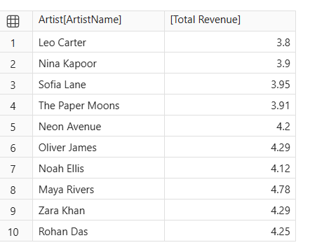
- Compare the revenue generated by different genres.
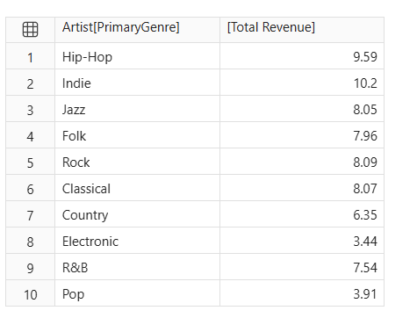
4. Identify the album with the highest listening activity.
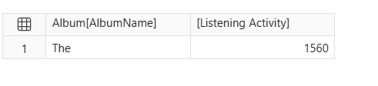

5. Analyse monthly stream trends
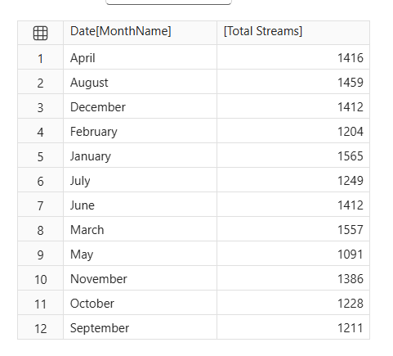
6. Compare revenue between 2024 and 2025.
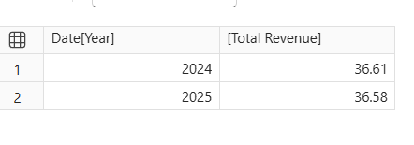

Dashboard Page 2 — Listener Behaviour and Revenue Analysis
Requirements
- Determine which subscription type generates the highest total revenue. 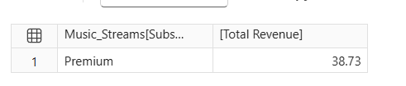

- Compare the average revenue per record for each subscription type.
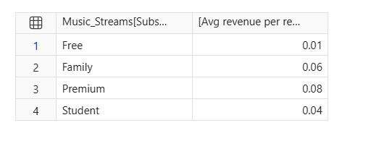
3.Identify which device accounts for the most streaming activity.
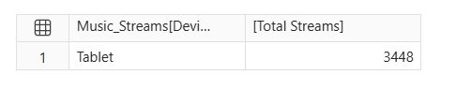
4. Compare listening behaviour across countries.
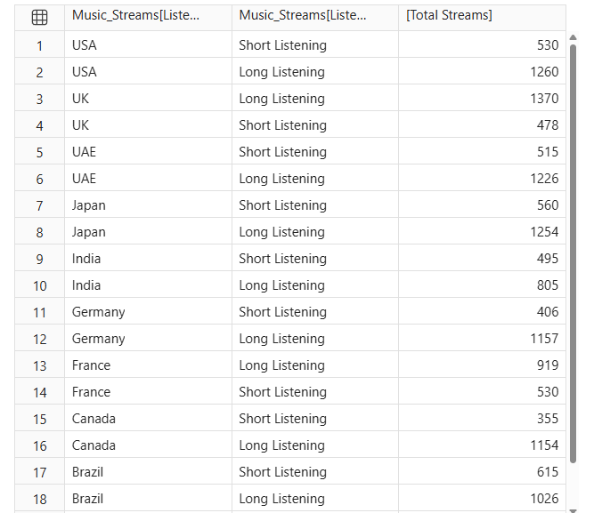

5. Find which playlist source has the highest number of streams.
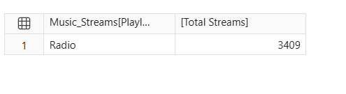

6. Compare completed and not-completed records
Based on the stacked bar chart we did earlier , we are analysing that
The chart shows that completed records are higher than not-completed records across all subscription types.
- Free: 505 completed and 352 not completed.
- Premium: 309 completed and 200 not completed.
- Family: 152 completed and 105 not completed.
- Student: 105 completed records.
Conclusion: Free subscription users have the highest number of completed and not-completed records. Overall, completed records are higher than not-completed records.
7. Analyse the relationship between SkipCount and Rating.
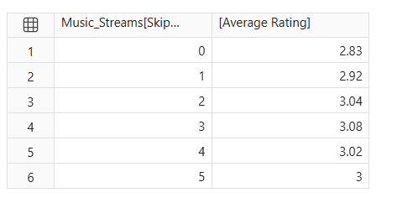
8. Compare revenue growth with the previous year.
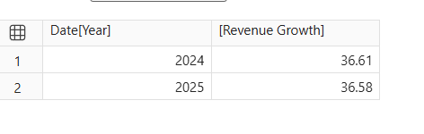
9. Identify artists or albums with high streams but relatively low revenue.



